## Merchant Name: AlphaAI Technologies DBA Tavily Implementation POC: Ali *(IM to fill)* CX POC: *[IMP to Add]*

### 

### 

| Notes Sections   *(AE to fill if they have, Implementation to be completion DRI on handoff)*   * Info on how merchant bills   + They have a PLG motion that Shai is not interested in bringing into Tabs through the integration. He is open to the idea in the future, but today he would like things to be separate   + Flat Saas platform fee   + Contract will include an amount of credits the customer has bought. The customer might go over this allotment and become a “pay as you go”. Shai plans to handle this in Stripe and potentially bring this to Tabs in the future. Not interested in this being done in Tabs today   + Additional product could be a security layer for 12 months that is also outlined in the contract   + The SLG motion is new, launched within the last couple of months   1) What is the merchant temperament?  Shai is relatively easy going and open to workflows aka he does not seem 100% set in his way. He is located in Israel (+7 hours to New York) but does work late at times  3) What are the Tabs features that the key POC cares about?   * Invoice generation * Revenue schedule automation * Avalara integration * Stripe integration * QB Integration * Hubspot * Plaid connection (Chase) |
| --- |

### Billing model *(Entire Section: Implementation to fill section)*

* Are there unique things about the customer creation process for this merchant?
* Information on how merchant bills
* How contract is broken up
* One off things to know about the merchant

### Contract Processing Steps *(Entire Section: Implementation/Success to fill Post-Go Live)*

1. Steps to process

**Customer Creation**

* Please make sure you are adding the billing contact and their email address to the customer profile
* Easiest to do this after you’ve created the customer on the “view customer” page



Click on “view customer” to update billing contact/email address. Primary contact/email can be a cc billing contact



**Should look like the below:**



Each distinct product or fee listed in the contract summary should be processed as a separate BT

**Item Name:** Use the label or description provided in the fee table or cost summary (e.g., "Enterprise Platform Fee," "API Credits - Growth Plan")

* label any product titled "Service Fee" (not in reference to sections titled "service fees") as “Enterprise Platform Fee”
* API Credits - Bulk Purchases **should** be processed as a flat fee BT if it is committed to
  + However, **do not** create any usage products for overage fees tied to API credits
  + Example below - ignore the section circled in red. Purple should be processed



* **Do not** process **API Credits-PayGo** products
  + The only thing that should be processed in the below is the Enterprise Platform Fee circled in green



**Item Description:** Optional; use only if helpful to clarify what the item covers or distinguish it from others

**Quantity:**

* Use stated quantity if given for API Bulk Purchase (e.g., "Credits Purchased: 300,000")
* Enterprise Platform Fee will almost always be 1
* Default to 1 if no quantity is listed or applicable

**Total Price:**

* Use the total cost for the listed item as shown in the agreement
* If there is a first-year discount or promotion, use the discounted value shown in the current contract year

**Service Start Date:**

* Use the "Order Form Effective Date" as the Service Start Date

**Months of Service:**

* Use the stated term for the agreement or item
  + Typically under “order form term”
* If not stated, default to 12 months

**Billing Start Date:**

* Default to Service Start Date unless a different invoicing schedule is clearly stated

**Integration Items:**

* Follow mapping below

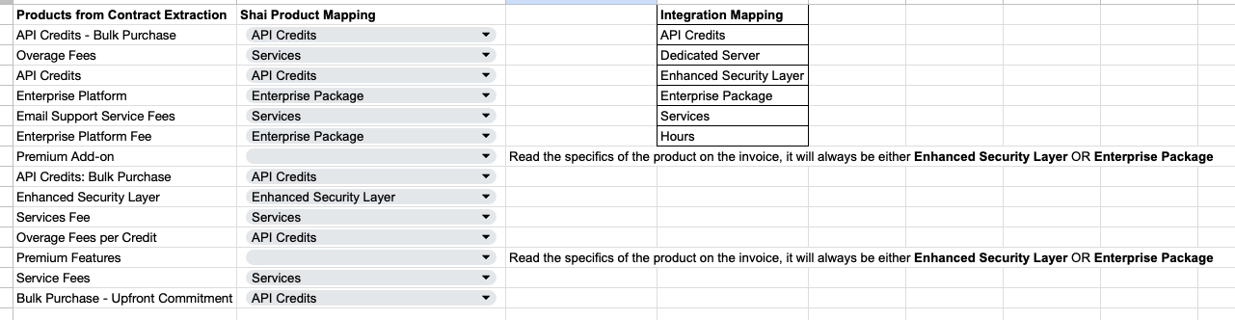

**Period & Frequency:**

* Check the billing frequency stated (one-time, annual, or monthly)
* Double check that the frequency you are using is for that specific product
  + For example, sometimes it will say that API-PayGo credits are billed monthly and not state explicitly that the enterprise platform fee is billed annually
    - Example below:
      * “Billing frequency: Monthly” is specifically for API-PayGo
      * However we **do not** process api-pay go credits
      * You can infer that “enterprise platform fee” is billed annually because it says “$5,250 / Year”
    - 
* Enterprise Platform Fee will almost always be “Year” (frequency) and “1” (period)
* Default to period, frequency “1, Year” if not stated

**Net Terms:**

* Use contract-stated terms
  + Usually under “Payment Terms”
* Default to 30 if not provided

**Billing Timing:**

* Bill first of period

1. Anything to ignore in contracts?

**Overage or “pay-go” fees:**

* Do not create usage BTs for overage pricing unless explicitly priced as a committed purchase in the contract
  + These are referenced for context only and not processed unless included in the contract's fee summary
* Ignore any upgrade rights or future optional items unless explicitly priced in the current contract term
* Ignore any terms about API credit expiration for BT creation purposes; expiration is not captured in BTs

Please read #3 below as well :)

1. Specifics processing things the merchant has requested that may differ by contract (e.g. always back-date invoice date to final day of the month)  
   **PO numbers!!!** If the contract/invoice has a PO number listed, please add it as an additional field to each invoice

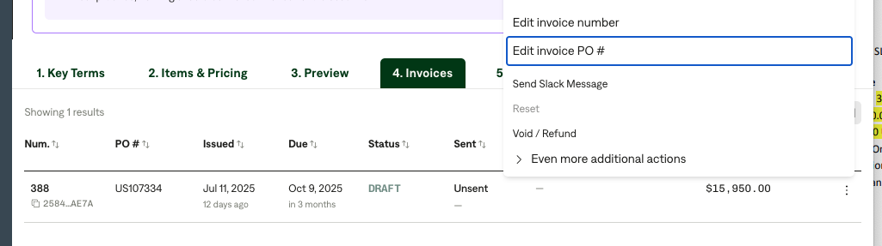

Example contracts:

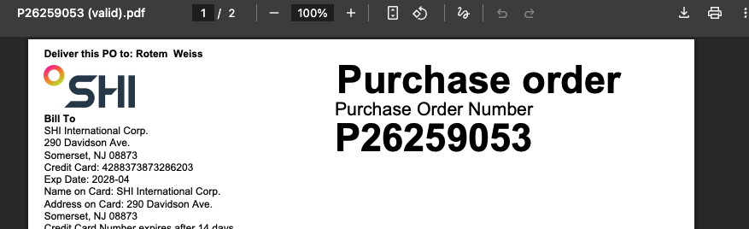



**Example Contracts:**

ba36ac09-31bb-47dc-a4fa-db62b11c1083

724e9cf3-2d07-4ee6-b5cc-f63cfd8a61b3

C7e60e78-6c27-4887-aa22-fecb1c8305e0

560a0828-4d84-4930-940f-88956514e585

1. Default Service Term
   1. If None Listed, Ops Default is 1 Year
2. Default Net Payment Terms
   1. If None, Ops Default is 0
3. Default Billing Frequency
   1. If None Listed, Ops Default is Monthly
4. How do we handle taxes as a line item?
   1. If None Listed, Ops Default is every tax line item becomes a BT

### Events Processing (if necessary) *(Entire Section: Implementation/Success to fill Post-Go Live)*

* Any important information on events billing

Integration Items Processing (if necessary)  
*(Entire Section: Implementation/Success to fill Post-Go Live)*

* What are the instructions for assigning integration items?
* Example: All Statsig integrations items should be labeled as “Sales”
* Example: All “Pinata” integration items should be labeled as “Software Subscription Bundle” unless otherwise noted by Merchant

Post Processing Communications (if necessary)  
*(Entire Section: Implementation/Success to fill Post-Go Live)*

* Does the Ops Team need to notify anyone on the team re: completion of processing batches in Implementation or Active phase?
* Who needs to be notified and when?
  + Example:
    - Who: Customer Success [Azmat Aziz] needs to be notified
    - Where: Messari internal merchant channel
    - When: contracts are processed [Merchant Phase: Active]

### Customer Information *(Entire Section: Implementation/Success to fill Post-Go Live)*

* Any important information on specifics customers of this merchant
  + Special memo’s certain invoices require
  + Invoice changes due to merchant/customer relationship

### Feature Requests *(AE to fill for all requests prior to Imp handoff, Imp to fill prior to go-live/Success to fill to fill Post-Go Live)*

* None that I am aware of or has been brought up

### Merchant Calls *(AE to fill for all videos prior to Imp involvement, Imp to fill prior to go-live/Success to fill to fill Post-Go Live)*

* [May 19](https://us-56595.app.gong.io/call?id=7946522177237830218&account-id=4521137177366317600)
* [May 20](https://us-56595.app.gong.io/call?id=88945710956983309)
* [May 28](https://us-56595.app.gong.io/call?id=2759265459793331010)